INFORMATIVO ADRROL (PG01)
ROLAMENTOS COM E SEM O CUBO. R O L A M E N T O S DE E M B R E A G E N S.
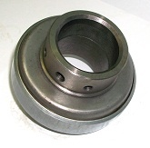 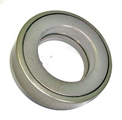 R-022 AGRALE VOLARE,MICRO BUS A\5 A8, CAMINHÕES SÉRIE 6000D
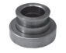 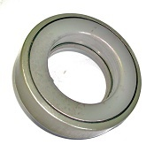 R-040 AGRALE MICRO ONIBUS 7000|7500| 8500-HIDRÁULICO.
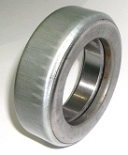 R-042 - AGRALE CAMINHÃO RS,DIESEL,1800FRD.
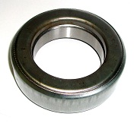 R-054- AGRALE RS DIESEL-93|94 R-056- AGRALE-RS DIESEL 1600.

R-057- AGRALE 4200-4300.
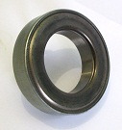 R-035-CHRYSLER-DODGE-D70-D750-D900-D950(4marchas)

(PG02)
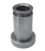 R-024-FORD SAPÃO-12000-14000—96 DIANTE.
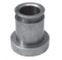 R-025-FORD CARGO-814(TODOS)F4000-F11000.
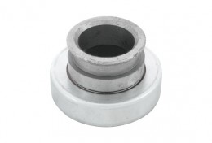 R-026-FORD-F600-750-4000-7000-perkins D63557|2-F1000-F7000-F11000-F13000-F14000-F19000-F19000mwm-D229\4-F21000-FORD MAXION.
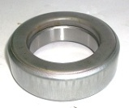 R-027-FORD-F150-F250-F350-P350-P400-F600-F1000 6 CIL-F4000 CIL-GALÁXIE-LANDAU.
R-037-FORD TC 55.
R-041-FORD CLAYSOM 1350-CLAYSON 1530-CLAYSON 4040-CLAYSON 5050.

(PG03)
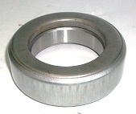 R-051-GENERAL MOTORS-D60-DETRIT.
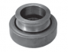 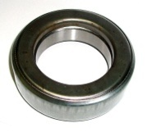 R-052-GENERAL MOTORS-D60-MAXION P6357\6358.

R-053-GENERAL MOTORS-A20-C20-C10-A10-C20--C14-C15-C20-C20-C40-C60-D10-D20-D60-D70-D74-D75-D78-S10.
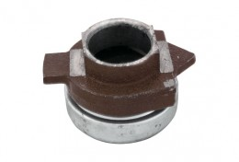 R-014-MERCEDES BENS-MB0352-OF1313-1314-1315-1318-1517-1513-1514-LP312-LP321-L1111-L1113-L1114-L2214-L2013-L2014.
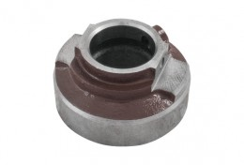 R-016-MERCEDES BENS-1114-1117-1118-1214-1218-1314-1318-1414-1817-1518-1624-1618-1718-2214-2218-2318-2418-O320-0371-0817-0h1114-of315-oh318-of1618-oh2418.
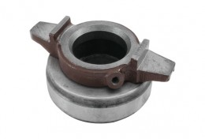 R-075MB-MERCEDES BENS- OM355|6LA - O370RSD O371RSD -1932-1033-1034-2425-2222.

(PG04)
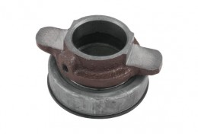 R-019-MERCEDES BENS-1013-1013-1017-1113-1213-1217-1413-1417-MOTOR OM353-06\77...508-D8-308-811-813-913-1617-MOTOR OM 352A-608-D708-709-808-OM 314-185CV-OM 353.
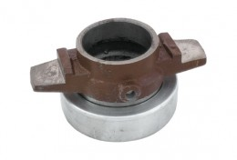 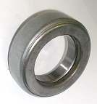 R-031-MERCEDES BENS-1519-1520-L LK LS 1524-1525LS-1819-1820LS-1924-1929LS. R-034-MERCEDES BENS-LP1520-L1519-1520-CS1525-1525—LG1819-LS1924-L1919-L2219-2220-OH1419-1420-OH1517-1518-O355-O364-365-COM355-O370-371.
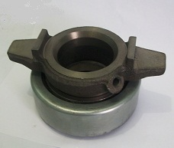
R-073 ADR.MERCEDES BENS-MotorOM355|6A – O370 – O371 RSD – 1525 – 1930 – 1929 - .Motor OM401 – 1719 – 1619 – 1919 – 1019 – MotorOM402 – 2232 – 20263 – 2626 – 1624 – 1625 – 1626 – 1424 – 2224 – Motor OM403 – 2632 – 3332 – 2224 – 2232 – 2032 – 2626 – 1623 – 1632 – 2624 – Motor OM421 – 2222 – 2222K – 1622 – 1922 – 1425 – 1428 – 1419 – 1422 – 1228 – 1225 – Motor OM422- 2628 – 3025 – 3028 – 3228 – 3235 – 3328 – 2228 – 2236 – 2025 – 2028 – 2425 – 1625 – 1628 – 1928 – 1425 – 1428 – 1228 – 1225.Motor OM 413 – 2632.MotorOM423-3335 – 3535 – MotorOM441 A\LA-3233.MotorOM442 442ª – 3336 – 3528 – 4435 – 4645 – 3535 – 1925.

(PG05)

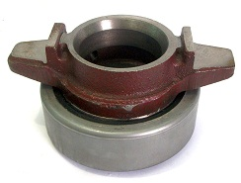 R-074-MERCEDES BENS 1518-1524-1525-1924-O370R ATÉ 1987-0370 U-O371 U\UP TODOS-OH1418-OH1419-OH1520-OH1520\2225.
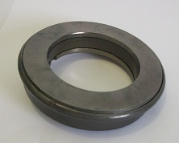 R-032-SCANIA-L110.
R-033-SCANIA-L110-L111.
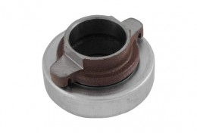 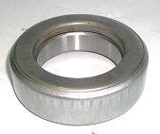 R-023-VOLKSWAGEN-6.90 ANO 74 DIANTE.
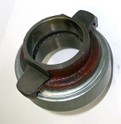 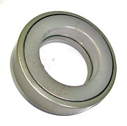 R-038-VOLKSWAGEN-11130-11140-12140-13130-14140-7110 VW MWM\PERKINS-D229...6.

R-O47-VOLKSWAGEN-16180.

(PG
R-030-VALMET-VALTRA-TODOS.
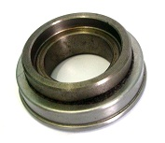 R-083-VALTRA VALMET-685 – 785 – 485 – 1180 - 885MWM4x4 -985 – 1180 – 1280 – 1580 – 1780 – 1380 – 1680 – 880 – 128 – 118 – 148.
R-060-VALTRA VAMET 685-785-880-885-980-985-1180.

R-062-VAMET VALTRA 128 – 138 - 148-1280 - 1580-1780-DISCO DUPLO.(dês)
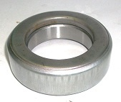 R-036-MAXION TRATORES 295|296|COLHEDEIRAS-1170DS-1175DS-1170DS.
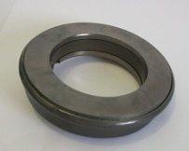 R-039-CBT TRATORES-2105|8060 4x4 – 8240-8240 – 8260 4x4 – 8440.

NT. R-059-CBT TRATORES 1090 – 1105 – 2100 – 2105 – 2400 – 2500 – 2600 – 3000 _8060 – 8240 – 8260 – 8440 – 8450.

(PG07)
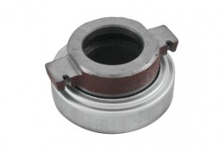 R-043-TOYOTA BANDEIRANTES 4x2 -4x4.
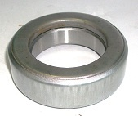 R-049-MASSEY FERGUSON – MF 50X.
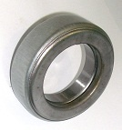 R-050-MASSEY FERGUNSON 265 – 275 - 290 - 292.
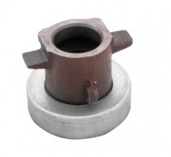 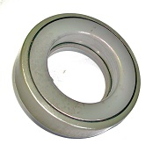 R-061-WILLYS RURAL – PICAPE – JEEP 1945 A 1957 – T-95-1968 em Diante.
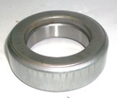 R-065-FORD TRATORES 4600-6600.
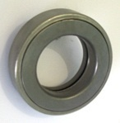 R-075-EMPILHADEIRA-TOYOTA-J I CASE-960 (82x44,22x21mm)

(PG08)
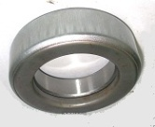 R-076-JOHN DEERE – AL2116.t – 2216 t. – 1284 t.TRATOR Série4020-68…75.
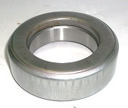 R-077-EMPILADEIRA HISTER H40 – 50 – 60K.
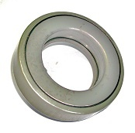 R-078-EMPILHADEIRA HUBER WARCO 130m.(95x54,22x22mm)
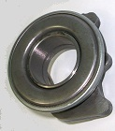 R-079-EMPILHADEIRA YALE SECA

R-080-HUBER WARCO-TODOS OS MODELOS,MENOS 130MM.

